PROTECTION AND PERMANENCY TRANSMITTAL LETTER, 15-05

TO: Service Region Administrators
Service Region Administrator Associates
Service Region Clinical Associates
Regional Program Specialists
Family Services Office Supervisors

FROM: Tina Webb, Assistant Director
Division of Protection and Permanency

DATE: April 3, 2015

SUBJECT: Referral for Services for Persons Diagnosed with a Serious Mental Illness

The purpose of this memorandum is to notify staff of a new online referral form, developed by the Department for Behavioral Health, Developmental and Intellectual Disabilities, for individuals diagnosed with a serious mental illness (SMI). This form has been created as a result of an interim settlement agreement between the Cabinet for Health and Family Services and Protection and Advocacy. The form’s function is to assess individuals who have been diagnosed with SMI to determine if they are eligible to receive integrated services that would allow them to:
- Move out of a personal care home; or
- Avoid being placed into one.
The link to this referral form has been added to SOP 20.2 General Interviewing Guidelines.

When completing the referral form, please follow the steps below:
- Open the In-Reach Referral Form;
- Complete all fields contained on the form, ensuring that the information is accurate;
  - The only field that may be left blank is the “Guardian” information section;
  - This field may only be skipped, if the information is unknown. If specific information, such as the guardian’s demographic and contact information is unknown, but information about whether or not the person has a guardian is available, the person completing the form should complete this portion of the section.
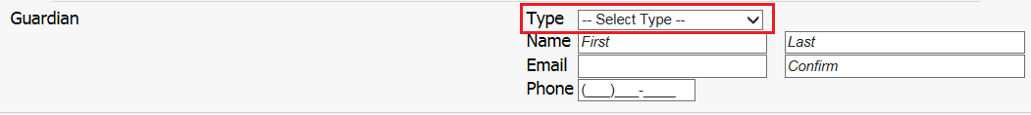
- After completing all fields, click the button at the bottom, left side of the page. A green checkmark will appear to indicate that the form has been successfully submitted.
- Once the referral has been submitted, an e-mail will be sent to the:
  - Person referring;
  - Assigned community mental health counselor; and
  - Interim Settlement Agreement Project Administrator.
- Staff from the Department for Behavioral Health, Developmental and Intellectual Disabilities, will complete the in-reach assessment within fourteen (14) days of receipt, whenever possible.
If you have any questions regarding this memorandum, please contact:

Steven Fisher, Adult Protective Services Branch Manager
Steven.fisher@ky.gov
(502) 564-7043, ext. 3570

